**Exercise 8: Implementing Basic AOP with Spring**

**Scenario:**

**The library management application requires basic AOP functionality to separate cross-cutting concerns like logging and transaction management.**

**Steps:**

**1. We have to define an Aspect:**

**o The we will create a package com.library.aspect and add a class LoggingAspect.**

**Ans.** Step 1: -Right-click on src/main/java and select New > Package.

Step 2: -Enter com.library.aspect as the package name and click Finish.

Step 3: -Right-click on the newly created package and select New > Class.

Step 4: -Enter LoggingAspect as the class name and click Finish.

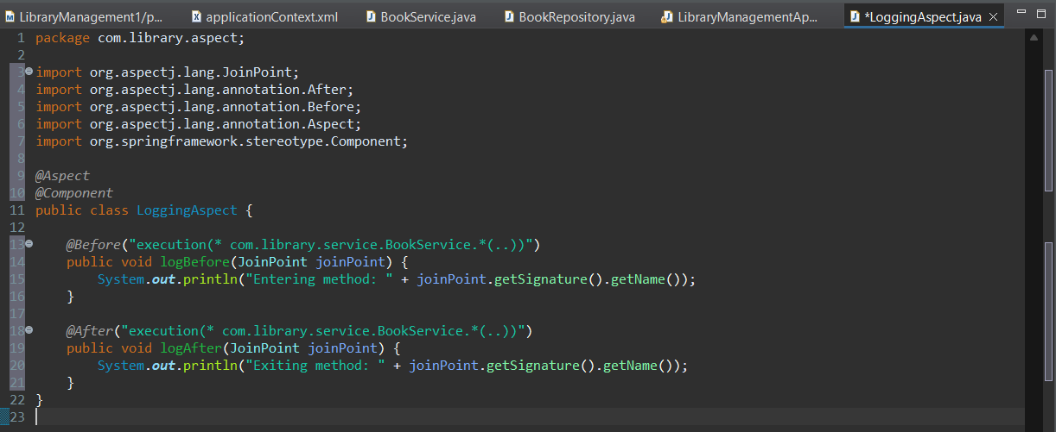

**2. Then We will create Advice Methods:**

**o Define advice methods in LoggingAspect for logging before and after method execution.**

**Ans.**

I have already this in in the “LoggingAspect” class above.

**3. Configure the Aspect:**

**o Update applicationContext.xml to register the aspect and enable AspectJ auto-proxying.**

**Ans.**

I have updated the applicationContext.xml to register the aspect and enable AspectJ auto-proxying.

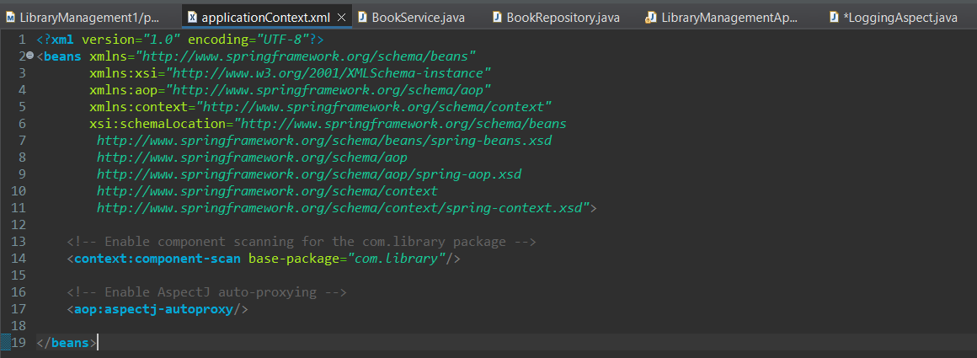

**4. Test the Aspect:**

**o Run the LibraryManagementApplication main class to verify the AOP functionality.**

**Ans.**

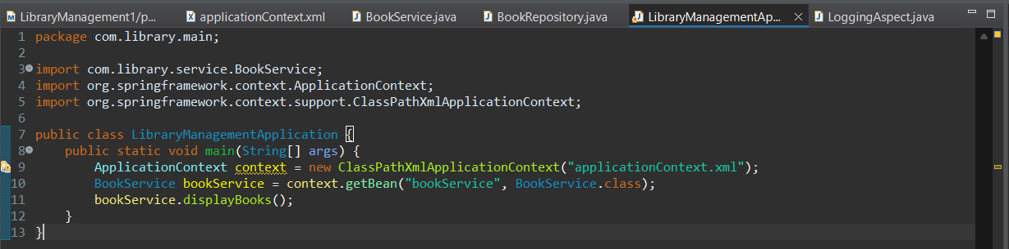

**Output:-**

